Dave Tate Day of Service
Bryan Park

Saturday, April 27 | 8:30-1, 80 volunteers

DAY OF CONTACTS

Parks Staff:  Floating: Kate Rivara; 804-350-3128  Michael Gee; 804-316-1529  Tree Planting: Qui Nguyen; 804-405-4543  Will Wickham; 804-551-1456  Front Entrance: Tiffany Concepcion;  Until 1:30 804-405-9571  & Drew Lopez  Southern Work Zone Boundary b/t Soccer and Market traffic : Ron Evans &  E Sears; 804-218-8075 | Volunteer Group  Andy Mason;  arboristmason@gmail.com  Phil Tate;  Phil.tate@brightview.com  Friends of Bryan Park  Lunch: Rick Sinsabaugh, President; 804-517-6734  Randy Smith  Trees: 804-833-4760

FACILITATOR CONTACTS
Tree Planting | Lunch | Tree Work
Randy Smith  804-833-4760  Qui, Will  + Tree Stewards | Rick Sinsabaugh  804-517-6734 | Brightview: Phil Tate  True Timber: Scott Turner  Arborscapes: Billy Davis  RW Stump: Reggie West  Commonwealth Tree Care:  Bartlett: Ethan Crockett  Davey: Robert Holiday
Landscaping Entrance | Trash Pick up | Debris
Brightview | Self -Serve | Urban Forestry:  Will Mayer  +2 technicians & Brush Truck  Park @ Keeper’s House

Saturday, March 23 – SCHEDULE

Set-Up/Prep
6:00 am – staff to arrive at reporting location to head to Bryan
7:00 am – Install barricade @ front entrance – Stationed here: Tiffany & Drew
8:00 am – Install barricade & Station on Rosina’s Lane between parking lot and median – E Sears & Ron
7:45-8:15 – Volunteers and arborists arrive, park, walk to Shelter 1

Welcome & Orientation
8:30 – Welcome from Andy & Phil

Place Volunteers
9:00 am – Volunteers to Task Zones

Lunch
FoBP – 11:45 begin set up

Wrap-Up
12:30 – Scott Turner reflections
12:45 – Parks thank yous (Chris Frelke)

SPECIAL INSTRUCTIONS:
- Parking:
  - Tree trucks to park directly in work zones.
  - UF truck at Keeper’s House.
  - ALL volunteers to park by Shelter 1.
  - Exceptions only for Tree Planting and Landscaping crews if they have materials to drop off. They must walk to and from Shelter 1 for kick-off/lunch.
  - Kabota can provide a ride for Randy Smith.
- Restrooms: Accessible porta potty at Shelter 1; Camphouse RR open for volunteers, Keeper’s House RR
- Rain Date: rain or shine. Cancelled in case of extreme weather.
- Medical: First aid kit at Shelter 1 and on Kabota. St Mary’s or MCV in case of emergency.

Task
Tree work : Arborists will report to their work zones to remove dead and dangerous limbs | 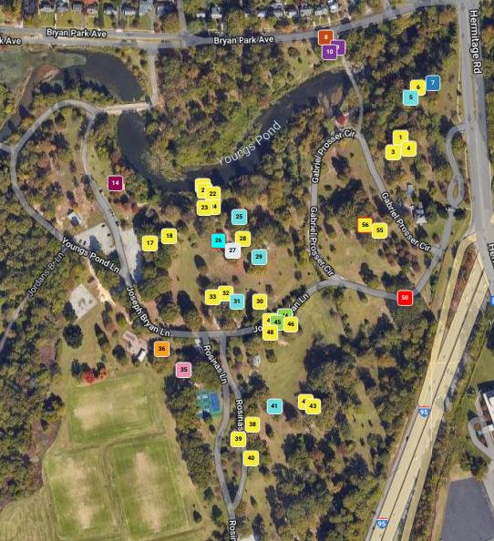
Brush hauling : Urban Forestry staff remove brush with claw truck | Park at Keeper’s House to wait for first pile. Follow behind tree work to stay out of active work zones.
Trash Pick up:  Young volunteers and family members of crews | Self- Serve. Trash grabbers and bags will be available at Shelter 1 and Keeper’s House for walking crews.
Landscaping entrance  Members of Brightview’s landscaping team will install new plantings at the stone gateway and apply fresh mulch. | 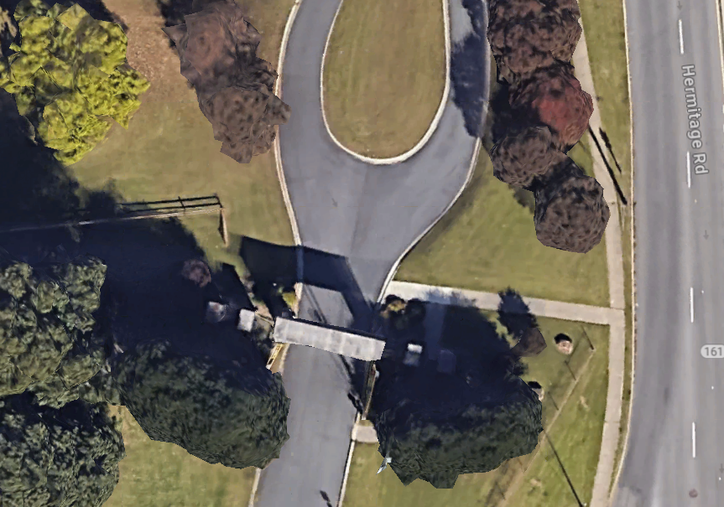
Mulch mounding: Any chipped debris will be deposited for later spreading | 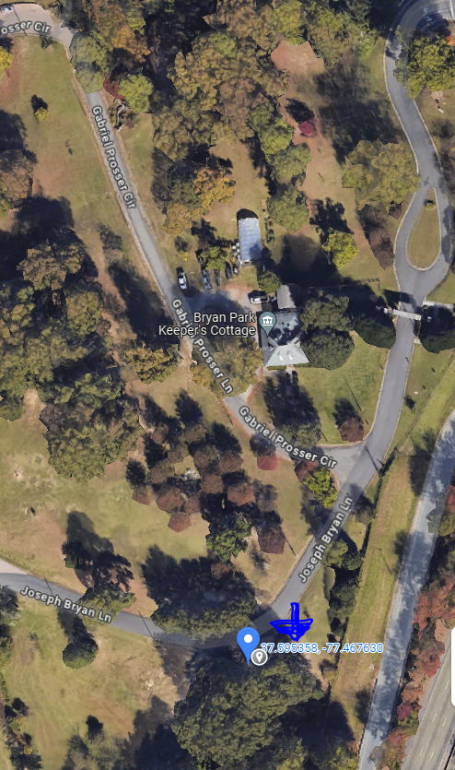
Tree planting:  - soaking tree diapers in water  - filling tree holes with soil and amendments  - packing down soil, while holding the tree upright  - installing tree diapers at the base of trees  - preparing protective wire tree cages for installation  - installing tree cages using two 5' hardwood stakes & fastening zip ties  - transport and distribute wood chips for protective mulch | 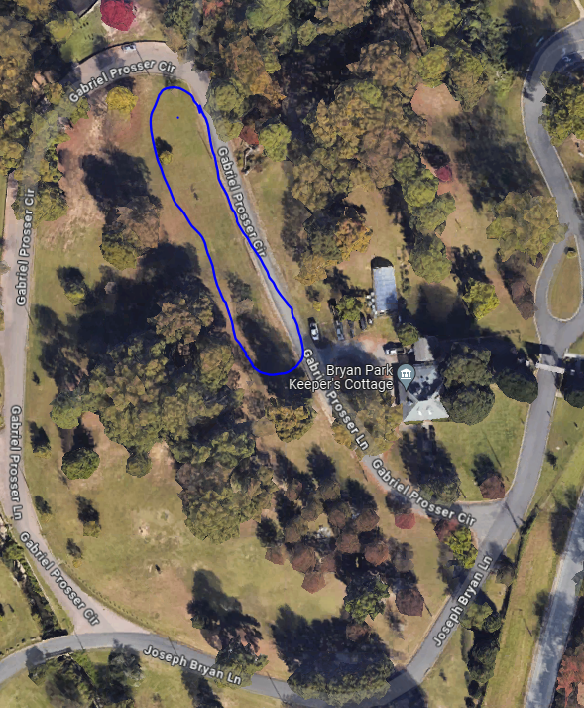
Hopper Projects (tree team)
- thinning the excess crowded trees (not pines, however), pruning invasives, dead branches, and vines from adjacent tree areas where mowing is not done
- constructing tree cages for other trees in the Park
- creating files of cleared brush & limbs for later removal

